The Art and Science of Low Carbohydrate Performance, Stephen Phinney and Jeff Volek
Section 1 THINKING DIFFERENT

Chapter 1 INTRODUCTION Humans Can Fly --

suffer from overtraining, have trouble recovering from your workouts, want to change your body composition, or simply want to experiment with how your body adapts to restricting carbohydrate, then this book is for “You”. -- Location 85

It’s an unfortunate reality that the human body is unable to promptly switch from carbs to fat as its predominant exercise fuel, so once the former is gone, you can’t power your performance with fat -- Location 98

Low carbohydrate diets are anti-inflammatory, producing less oxidative stress during exercise and more rapid recovery between exercise sessions. -- Location 132

Physiological adaptation to low carbohydrate living allows much greater reliance on body fat, -- Location 133

Low carbohydrate adaptation accelerates the body’s use of saturated fats for fuel, -- Location 134

At the practical level, effective training for both endurance and strength/power sports can be done by individuals adapted to carbohydrate restricted diets, with desirable changes in body composition and power-to-weight ratios. -- Location 136

Chapter 2 METABOLISM BASICS A Functional Look At Fuel Use

This suppression of fat oxidation lasts for days after carbohydrates are consumed, not just the few hours following their digestion when insulin levels are high. -- Location 155

In order to sustain a high level of performance under conditions of glycogen depletion and decreased glucose availability, cells must adapt to using fat fuels. -- Location 157

Adenosine tri-phosphate (ATP) is the chemical energy that fuels body processes including muscle contraction. -- Location 180

Since we can’t store (nor do we eat) ATP in appreciable amounts, exercise causes an immediate need to rapidly make ATP from other energy sources. The two primary fuels our bodies draw on to do this are carbohydrate and fat. -- Location 182

The more carbs that are available, the more carbs the body burns; while at the same time shutting down access to its much larger fuel reserve – fat. -- Location 185

On average, the maximum glycogen store you can accumulate is between 400-500 grams. And since 1 gram of carbohydrate equals 4 kcal, you max out at about 1600-2000 kcal in your carbohydrate fuel tank. -- Location 190

Fat, or more specifically fatty acids, are stored in the body as triglycerides consisting of three fatty acids linked to a single 3-carbon glycerol. -- Location 196

Even in a very lean athlete, the total amount of energy stored as fat will typically be more than 20 times the maximum level of carbohydrate stored in the body. -- Location 199

Thus, whereas vigorous exercise can deplete glycogen reserves in just a few hours, when adapted to burning primarily fat, this thin athlete has enough fat to fuel several days of exercise. -- Location 200

Why can’t this surplus of fat fuel be utilized even at a time when the body desperately needs -- Location 208
- it can be accessed, but it takes a few weeks of carbohydrate restriction during which time the body becomes significantly more efficient at burning fat, a process we call keto-adaptation -- Location 209
- As the name implies, this process involves the conversion of fat to ketones in the liver, and these ketones help supply the brain with energy when glucose levels fall. This affords even a very lean (10% body fat) athlete access to more than 40,000 kcal from body fat, rather than starting a prolonged event depending primarily on ~2000 kcal of glycogen. -- Location 211

How You Burn Body Fat: Fat Breakdown -- Location 214
- Although many factors stimulate the activity of hormone-sensitive lipase (e.g., epinephrine, norepinephrine, growth hormone, activated thyroid hormone), fat breakdown is principally controlled by the single hormone that inhibits its activity. That hormone is insulin. -- Location 217
- fat. If your insulin levels are consistently high, fat usage is effectively blocked. -- Location 220
- The primary nutrient that stimulates insulin is dietary carbohydrate. -- Location 221
- focusing on keeping insulin low is associated with significant changes in fat metabolism, favoring decreased storage and increased fat oxidation. -- Location 226
- insulin’s effect on fat breakdown does not take days or even hours, its effect is virtually immediate. -- Location 227
- Keto-adaptation, however, is not immediate. Keeping insulin low is a first step in increasing fat availability, but to maximize fat burning the body requires at least a couple weeks of uninterrupted low insulin levels (i.e., 2-3 weeks of consistently restricting dietary carbohydrates). -- Location 228
- Factoid: In the well-trained athlete, muscles cells can store as much energy in fat droplets as they can store as glycogen. -- Location 239
- you will find that the peak rate of fat burning (grams of fat oxidized per minute or per hour) occurs on average at about 50% of maximal oxygen consumption (VO2max) if you’re untrained and at 65% VO2max if you’re trained[5]. -- Location 250
- Exercise harder and although power output increases, the contribution of fat decreases, forcing carbohydrate to become the predominant fuel source. 65% of VO2max is an intensity most endurance athletes can easily maintain for several hours. -- Location 252
- Typical fat oxidation rates as a function of increasing exercise intensity. -- Location 259
- There are remarkable differences among individuals in both the magnitude of peak fat burning and the intensity of the exercise at which peak fat oxidation occurs. -- Location 273

Chapter 3 A TECTONIC SHIFT IN THINKING Keto-Adaptation: The Most Efficient Path To Accelerated Fat Burning --

- Ketones are an important lipid-based fuel source, especially for the brain, when dietary carbohydrates are restricted.
- The process of keto-adaptation (switching over to using primarily fatty acids and ketones) can’t be done ‘on the fly’ – it takes at least 2 weeks of preparation for this strategy to work.
- Keto-adapted athletes show marked increases in fat burning, indicating that peak rates of human fat oxidation have been significantly underestimated.
- Keto-adapted individuals can do resistance training, and show profound improvements in body composition. -- Location 311

Today, however, a combination of time-tested experience and recent research data supports the conclusion that if humans are given two or more weeks to adapt to a well-formulated low carbohydrate diet, they can deliver equal or better endurance performance compared to the best high carbohydrate diet strategy. -- Location 323

When we say ketones we are referring to two 4-carbon molecules – beta-hydroxybutyrate (BOHB) and acetoacetate (AcAc). -- Location 340

BOHB and AcAc are made in the liver from fatty acids, and chemically they retain some similarities to the fatty acids from whence they come. -- Location 341

However, being much smaller molecules, they are water soluble, making them easier to transport in the blood -- Location 342

On average keto-adaptation resulted in peak fat oxidation rates of 90 g fat/hour – 50% greater than the highest recorded value for any participant in Venables’ study. -- Location 367

Metabolic adaptations to increase peak fat oxidation can be increased by training, but there remains a large untapped potential in even the most highly trained athlete that can only be achieved by keto-adaptation. -- Location 371

Ketone production occurs mainly in the liver in response to a combination of increased delivery of fatty acids and depletion of hepatic glycogen reserves. -- Location 383

The ketones produced in the liver are then transported by the circulation to other cells in the body including muscle and brain. -- Location 384

In skeletal muscle, the first few days of keto-adaptation result in increased use of both ketones plus fatty acids from a variety of sources (adipose or intra-muscular triglycerides, or from circulating very low density lipoprotein particles). -- Location 384

Once the process of keto-adaptation is complete (which takes from a few weeks to a month), muscle both at rest and during exercise comes to rely heavily on fatty acids. -- Location 386

This is a key point. Practically speaking, the brain can burn only glucose or ketones. -- Location 388
On a very low carbohydrate diet, the brain comes to rely on ketones as its primary fuel. - Location 389

because of the large mass of skeletal muscle and the increase in blood flow to active muscles during exercise, this delayed shift of the muscles away from ketones and towards fatty acid use is vital to preserving fuel flow to the brain during exercise in the keto-adapted athlete. -- Location 390

The combination of a very low carbohydrate diet and resistance training results in the largest decreases in percent body fat. -- Location 406

Chapter 4 KETO-ADAPTATION Metabolic Benefits And Sports Implications -

- Keto-adaptation provides a steady and sustained source of fuel for the brain, thereby protecting athletes from hitting the wall.
- Keto-adaptation may improve insulin sensitivity and recovery from exercise.
- Keto-adaptation spares protein from being oxidized thereby preserving lean tissue.
- Keto-adaptation decreases the accumulation of lactate, contributing to better control of pH and respiratory function.
- The benefits of keto-adaptation may be relevant for improving endurance, strength/power, and cognitive performance, as well as speeding recovery. -- Location 424

Brain Fuel. In order for the body to shift from glucose to fat for fuel, there need to be alterations in inter-organ fuel exchange – the process that partitions lipid fuels to specific sites for oxidation. -- Location 441

when blood ketone levels are low, muscle uptake is high, whereas at higher levels, muscle uptake is reduced. -- Location 446

Thus, when the oxidation of ketones in skeletal muscle is reduced, blood ketones rise. This adaptation facilitates an increase in ketone transport across the blood brain barrier to meet the majority of energy demands of the brain. -- Location 451

A low carbohydrate diet that increases ketone levels above 1 millimolar (typical of someone eating less than 50 g/day of total carbs) increases expression of monocarboxylic acid transporters levels eightfold in rat brain cells[18] and also increases brain uptake of ketones by a similar magnitude[19] accounting for over half the brain’s fuel use. -- Location 452

And there you have the paradox of nutritional ketosis – blood pH and respiration are actually better controlled when your body has adapted to ketone-based energy flow, even though ketones are technically acid compounds. -- Location 533
Chapter 5 EXERCISE RECOVERY Returning Rapidly To Full Function --

- Avoiding wide excursions in blood sugar and insulin by burning predominately fatty acids and ketones can lessen the ‘stress’ response to exercise.
- Keto-adaptation results in less generation of reactive oxygen species (ROS) and therefore better preservation of highly unsaturated fatty acids (HUFA) in cell membranes.
- Less metabolic stress, improved fuel flow, and healthier membranes translate into faster recovery from exercise and less exercise-induced inflammation, immunosupression, gastro-intestinal distress, insulin resistance, muscle damage, and soreness.
- Maintaining adequate membrane HUFA status can be further supported by ensuring adequate intake (via your diet or supplements) of omega-3 HUFA and antioxidant/anti-inflammatory compounds like the ‘gamma form’ of vitamin E. -- Location 620

A provocative way to think about ketones is that they are a clean-burning fuel, in that their production and oxidation appears to result in less generation of reactive oxygen species (ROS) compared to other metabolic substrates like glucose and glycogen. -- Location 631

ROS (aka oxygen free radicals) are highly reactive molecules produced by mitochondria that damage tissue proteins and membrane polyunsaturated fats. -- Location 633

BOHB levels in the blood within the range of nutritional ketosis (1-3 millimolar) decreases mitochondrial ROS production[32] and increase antioxidant defenses[33]. -- Location 634

Section 2 IMPLEMENTING YOUR DIET PLAN

Chapter 6 CARBOHYDRATE Why It Is Unnecessary And How To Restrict It --

- Although variable from person to person, to get your blood ketones above 1 millimolar typically requires that you consume less than 50 grams of carbohydrate per day.
- In the context of a well-formulated ketogenic diet, this level of carbohydrate restriction is safe, sustainable, and satisfying.
- As you become aware of the carbohydrate content of foods, you’ll discover that an appealing variety of meals can be consumed even at this low level of carbohydrate intake.
- Whereas consuming fast-digesting carbohydrates after exercise is commonly recommended, this practice is counter-productive in the keto-adapted state.
- Once keto-adapted, depending on your metabolism and goals, you may be able to incorporate slow release sources of carbohydrate such as root vegetables, legumes, or UCAN’s SuperStarch™. -- Location 700

blood sugar can be well-maintained via metabolic processes such as gluconeogenesis without dietary carbohydrates in the keto-adapted human. -- Location 733

In our clinical experience, the ‘Nike approach’ is better. Particularly if you use broth/bouillon to get enough sodium and eat plenty of low carb vegetables to get enough potassium, your adaptation period will be short and relatively symptom-free. -- Location 763

Well, for starters, when it comes to cereals, breads, pasta, potatoes, pastry, candy, juices, or other carb-dense foods we’ll say it once...just don’t go there. Because all of these are like the nuclear option in suppressing ketones, we’ve started calling them ‘carbage’. -- Location 768

generally, your daily carbohydrate count should total something like this: 5-10 grams from protein-based food 10-15 grams from vegetables 5-10 grams from nuts/seeds 5-10 grams from fruits 5-10 grams from miscellaneous sources -- Location 772

Meats and cheeses have virtually no carbohydrate with the exception of small amounts in glycogen and lactose, respectively. -- Location 775

Whole eggs contain about half a gram of carbohydrate each and can be used frequently. -- Location 785

Select hard cheeses or cream cheese with less than 1 gram of carbohydrate per ounce. -- Location 786

Cream (half & half, light or heavy whipping cream) can be used in place of milk for coffee, protein shakes, smoothies, etc. -- Location 786

Search for a plain Greek yogurt or unsweetened live culture plain yogurt made from whole milk containing 10-16 grams of carbohydrate per cup. -- Location 787

Eating lactate as opposed to lactose does not raise insulin or interfere with ketosis. -- Location 792

Cottage and ricotta (non-fermented) cheeses should be used sparingly. -- Location 794

You can enjoy many different types of vegetables but avoid the starchy ones like potatoes, yams, sweet potatoes, corn, carrots, beets, dried beans and peas. -- Location 796

Most nuts, nut butters, and seeds contain about 4-8 grams of carbohydrate per ounce so limit yourself to 2 ounces per day. -- Location 808

Berries (e.g., rasp-, straw-, blue-, etc), tomatoes, olives and avocados are relatively low in carbohydrate and packed with nutrients. A daily total of up to 100 grams (3.5 oz) of these berry fruits can be consumed. -- Location 812

Consuming even small amounts of carbohydrate after exercise rapidly decreases the release of fatty acids from fat stores and oxidation of fat in the muscle[40], thereby interfering with keto-adaption, plus also diminishing the beneficial effects of exercise on insulin sensitivity and other cardio-metabolic risk markers[ -- Location 840

Chapter 7 PROTEIN Necessary, But In Moderation --

- Too little or too much protein can be problematic in the keto-adapted state.
- Aim for a protein intake between 0.6 to 1.0 grams per pound of lean body mass.
- Rather than consume large portions of meats or other protein foods, focus on small to moderate protein portions and combine them with generous portions of good sources of fat (e.g., sauces, butter, olive oil). -- Location 868

consuming somewhat more protein than the recommended dietary allowance is probably justified if you are losing weight or frequently doing high stress exercise. -- Location 878

blood levels of leucine increase in the keto-adapted state, so sustaining a state of nutritional ketosis (by not eating carbs after exercise) will protect this benefit. -- Location 903

To determine the protein content of bulk foods, however, it helps to use ‘the rule of sevens’. As a general estimate, one ounce of meat, fish, or poultry contains 7 grams of protein. -- Location 908
- A cup of fermented dairy (yogurt, buttermilk), an ounce of cheese, 2 ounces of nuts, a cup of home-made broth, and a large egg each contain about 7 grams of protein. -- Location 909

Chapter 8 FAT Your Most Important Fuel --

- To maintain nutritional ketosis, as a proportion of total calories, your fat intake will need to be high (~65 to 80%).
- Since your amounts of carbohydrate and protein are locked into a relatively narrow range, the amount of fat you eat will vary depending on whether you want to lose or maintain weight.
- The fat you eat provides important fuel and therefore should emphasize the fuel sources the body prefers to burn, namely monounsaturated and saturated fats.
- Limit foods with a high proportion of the vegetable (omega-6) polyunsaturates.
- Balance your intake of omega-6 and omega-3 polyunsaturated fat. -- Location 914

Therefore a key to successful keto-adaptation is figuring out ways to specifically increase your fat intake without over-consuming carbohydrate and protein. -- Location 923

how much fat you consume will be dictated by your energy demands, body weight and composition goals, and satiety. -- Location 931

it’s usually not necessary to count fat calories. Once keto-adapted, most people report that hunger and cravings are reduced. -- Location 934

The Right Types of Fat -- Location 937
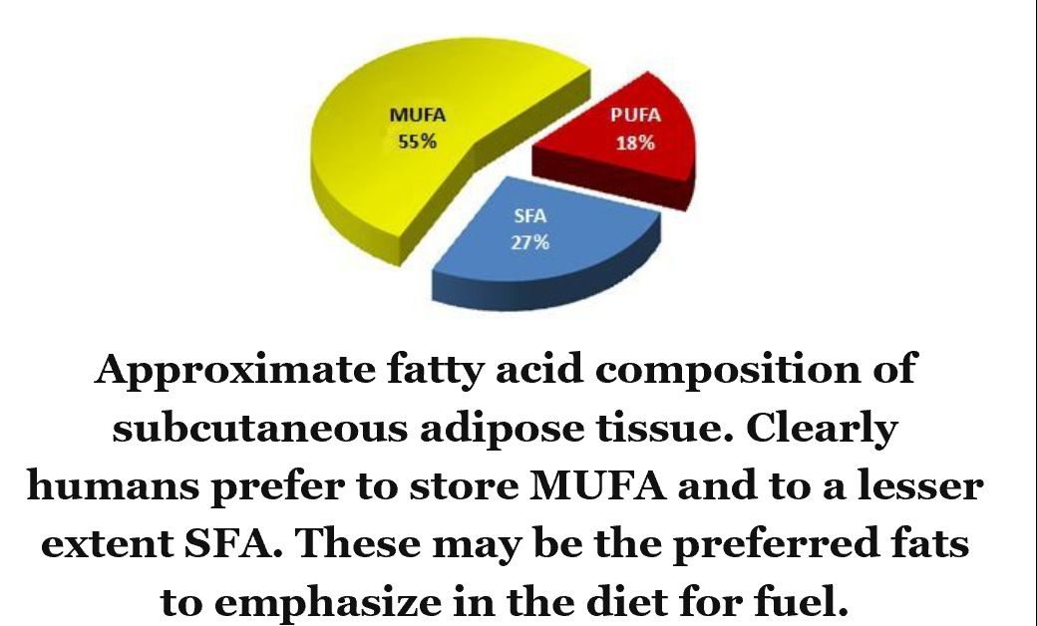

Fats (or more specifically fatty acids) are generally classified as saturated (SFA) that contain no double bonds, monounsaturated (MUFA) that contain one double bond, and polyunsaturated -- Location 941
- (PUFA) that contain more than one double bond. -- Location 943
- The fatty acids that make up the majority of triglycerides in human adipose tissue consist of SFA and MUFA. -- Location 947
A 50:50 mixture of butter and olive oil approximates the composition of triglycerides typically found in human body fat. -- Location 951

widespread belief that dietary saturated fat is harmful turns out to be an out-dated paradigm based upon flawed reasoning. -- Location 954

Among the polyunsaturated fats, there are two essential classes called omega-3 and omega-6. The actual human requirement for these two forms of PUFA is low – about ~1% of daily energy from each of these two classes. -- Location 963

Increasing omega-3 status consistently leads to lower levels of inflammation, and it also has a potent effect on lowering fat levels (triglycerides) in the blood. -- Location 970

the human system doesn’t seem to tolerate a high fat diet prepared from high omega-6 oils (like soy and corn oils), but does just fine on one consisting mostly of monounsaturated and saturated fats (e.g., olive oil and animal fats). -- Location 994

Practical Guidelines on Consuming Fat -- Location 1004
- Fats and Oils. Purely fat-containing foods vary widely in their composition. The best oils to use are those that are low in PUFA, such as olive, canola, ‘high oleic’ safflower, coconut and palm. Steer clear of corn, soybean, cottonseed, peanut, and safflower, as well as margarines and mayonnaise made with any of these oils. -- Location 1006
- Butter and fat from beef (tallow) or pork (lard) are also excellent choices, -- Location 1009
- Animal fats such as those in meats, eggs, and dairy are relatively low in PUFA and good sources of SFA and MUFA. Other good sources of fat are olives, avocados, heavy cream, sour cream, nuts, seeds, and cheese. -- Location 1012
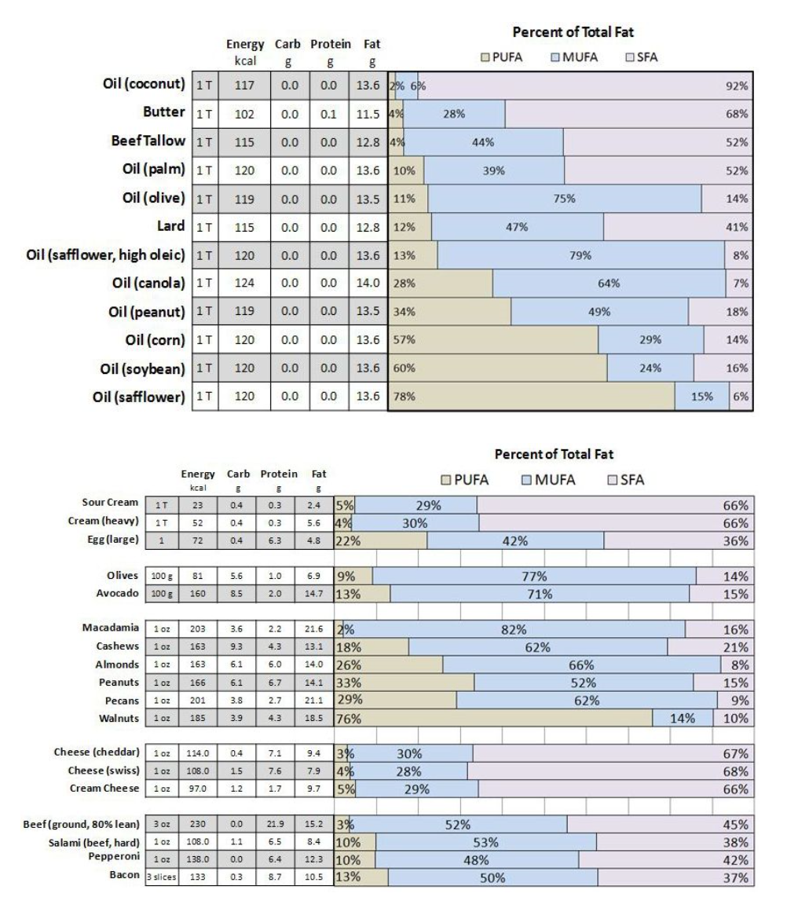

Practical Guidelines for Omega-3 Intake -- Location 1016
- The minimum dose to start is 500 mg of EPA plus DHA per day, which is equivalent to about one serving of fatty fish every other day. -- Location 1018
- Fish from cold water are the richest source of the main omega-3 fats (EPA [20:5] and DHA [22:6)] that we need to maintain healthy membranes. Good sources of these fatty acids are salmon, tuna, sardines, and herring. -- Location 1021
- A readily available alternative to eating fish or fish oil capsules is omega-3 eggs. -- Location 1025
- resulting in 100-150 mg of EPA + DHA per egg. -- Location 1026
- Ideally we encourage you to test your blood or cheek cells for EPA and DHA content (http://www.omega3test.com/) (see Chapter 10). -- Location 1028

Chapter 9 FLUID AND MINERAL MANAGEMENT Why Micronutrients Can Have A Macro-Effect -

- Low carbohydrate diets increase the loss of sodium and water by the kidneys.
- Failure to adequately replace sodium adversely affects potassium balance and has several negative effects (e.g., fatigue, fainting, headache, loss of lean mass).
- The easiest solution is to consume an extra 1-2 grams of sodium per day in the form of 2 bouillon cubes (or home-made broth).
- Most muscle cramps are due to magnesium depletion in cells. Adequate magnesium intake helps prevent cramps.
- A 20 day course of slow-release magnesium supplementation effectively treats most muscle cramps.
- Dietary magnesium and potassium (as well as other micronutrients) can be increased by appropriate preparation of meats and vegetables. -- Location 1035

Sodium -- Location 1048
- Sweat too much and your body runs short of sodium, and this forces it to shrink your blood volume to keep serum sodium concentration in the normal range. Shrink your circulating volume too much and you pass out. -- Location 1053
- The easy solution is to routinely take 1-2 grams of sodium per day in the form of 2 bouillon cubes (or home-made broth). -- Location 1063
- Some bouillon cubes contain less than 1 gram sodium so be sure to check. On days that you exercise, be sure to take one dose of broth or bouillon 30 minutes before your workout. -- Location 1064
- If you are worried about your blood pressure, get a cuff and measure it to be sure it stays normal (which it usually does on a ketogenic diet). -- Location 1078

Potassium -- Location 1081
- There’s as much potassium in 4 oz of meat as in a medium banana or 8 oz of orange juice. -- Location 1084
- However the Achilles heel of meat and vegetables as potassium sources is how they are prepared. Boil either one and much of the potassium is lost in the broth. If you grill your meat to medium well done, much of the potassium leaves with the drippings. -- Location 1084
- A chicken carcass boiled for a few hours gives up much of its potassium to the broth, as is true for beef bones and scraps as well. -- Location 1089

Hydration -- Location 1091
- The solution is to drink 1-2 cups (250-500 ml) of water about 5 minutes before starting – long enough for most of it to be absorbed but too soon for your kidneys to start clearing it. Once exercising, kidney blood flow goes way down, so that initial priming dose of water is retained and supports the early exercise plasma volume expansion. -- Location 1095

Magnesium -- Location 1100
- Magnesium resides inside our cells. There is very little of it in serum, so blood tests for this mineral can’t tell us if we are okay or not. -- Location 1103
- Magnesium calms muscles (including the heart), nerves, and the brain. -- Location 1105
- magnesium is the mineral at the core of chlorophyll – the green stuff that makes photosynthesis (and thus all sunlight-powered life) possible. The darker green the vegetable, the more magnesium it contains. But if you boil it until it’s mushy, when you throw away the water, you throw away much of the magnesium. -- Location 1110
- Take 3 slow-release magnesium tablets daily for 20 days. The proprietary brand-name product is ‘Slow-Mag’ ™, but there are a number of equally effective generics now available at a fraction of the brand-name price (e.g., Mag-64™ or Mag-Delay -- Location 1117
- magnesium gluconate (another popular magnesium supplement) is mostly ‘gluconate’ (a form of sugar), -- Location 1125

Zinc -- Location 1128
- Signs of zinc deficiency are severe dry skin, horizontal depressions across the fingernails, and recurrent skin warts -- Location 1131
- This means that taking lots of iron for months at a time blocks absorption of zinc, even if there is plenty of zinc in your diet. -- Location 1139

Chapter 10 PERSONALIZATION Finding Your Ketone Zone And More --

- To achieve optimal fuel flow during keto-adaptation you should aim for blood ketone levels between 0.5 and 3.0 millimolar.
- The most practical, accurate, and fast way to test ketones is to use a hand held monitor that measures BOHB in a drop of blood.
- Several factors act to increase blood ketones including restricting carbohydrate, keeping protein moderate, exercise, and ingestion of medium chain triglycerides found in butter and coconut oil.
- Monitoring body composition using dual-energy x-ray absorptiometry (DXA) is the most accurate way to assess changes in whole body and regional fat, lean, and bone mass.
- Measuring specific blood fatty acids (and perhaps noninvasively in cheek cells) provides individualized guidance on carbohydrate intake, omega 3 status, and overtraining. -- Location 1158

As carbohydrates are decreased to below 50 grams per day and protein is not consumed in excess, most people will produce ketone levels >0.5 millimolar. -- Location 1173

Taking these factors in combination, a therapeutic range of blood ketone levels for an athlete starts at 0.5 millimolar BOHB at the lower end and improves up to 3.0 millimolar. There do not appear to be any benefits to pushing blood ketones higher than 3 millimolar, which is about as high as most people get eating a well-formulated ketogenic diet. -- Location 1181
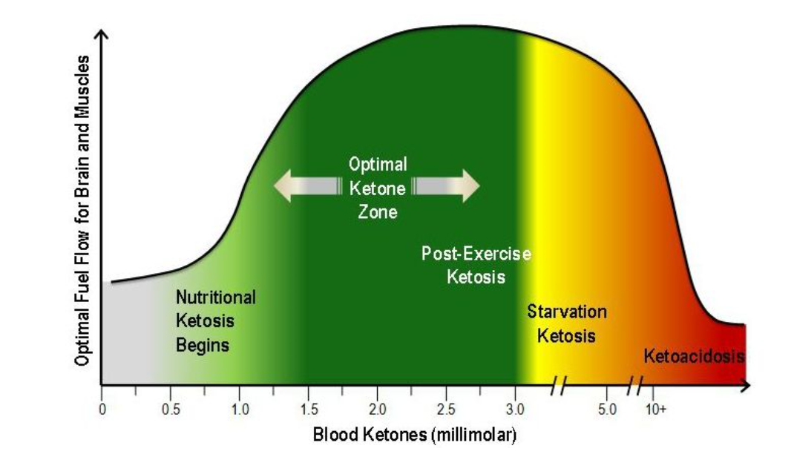

Monitoring Ketones -- Location 1185
- Blood tests for ketones are more definitive since they measure the concentration of BOHB, AcAc, or both, where it is most important – directly in your circulation. -- Location 1194
- Precision Xtra® (Abbott Diabetes Care, Inc) and Nova Max® Plus (Nova Biomedical) are reasonably priced devices (~$20) available ‘over-the-counter’ that can test for levels of BOHB and glucose in a matter of seconds. -- Location 1197
- However, reagent strips for BOHB are relatively expensive (~$3 to 5 per strip) if purchased at retail drug stores. On eBay, however, it is possible to buy these same blood ketone strips for $1-2 each. -- Location 1199
- Exercise. If you test your blood ketones after exercise, they usually increase between 0.25 - 0.5 millimolar indicating effective stimulation of fat burning. -- Location 1225
- Ketone levels increase sharply during the 1-2 hours after exercise due to increased hepatic delivery of fatty acids and greater rates of fat oxidation. -- Location 1227
- After a marathon, even an athlete who has carbohydrate loaded and consumed sugars along the course may have blood ketones up to 0.5mm when crossing the finish line. However getting ketones up to this threshold level by running for a few hours does not achieve keto-adaptation – that still takes a couple of weeks of sustained low carb intake. -- Location 1232
- In people adapted to a very low carbohydrate diet, there also appears to be a small diurnal variation in ketones with lowest levels observed in the morning after an overnight fast with levels gradually increasing over the day. -- Location 1235
- Other work in healthy adults has shown gradual increases in blood ketones over the course of the day and more rapid increases after meals low in carbohydrate and high in fat[ -- Location 1238

Medium Chain Triglycerides. -- Location 1240
- MCT have three very important distinctions from LCT.
  - First, they are absorbed much more quickly.
  - Second, MCT don’t get stored in fat cells, so once consumed, they need to be processed immediately.
  - Third, MCT are not dependent on the same regulatory factors that control LCT entry into cells and mitochondria; so MCT are promptly oxidized in muscle cells or used by the liver to make ketones. -- Location 1242
- Natural sources of MCT are dairy fats (e.g., butter and cream) and coconut oil, so you may find your ketones go up more after ingestion of these foods. -- Location 1245

Among the tests available, dual-energy x-ray absorptiometry (DXA) is the most accurate and provides additional information beyond other common body composition methods. -- Location 1254

A DXA scan provides information about whole body and regional lean and fat tissue, as well as bone mass. For example, specific information can be provided about fat content in the abdominal area. -- Location 1257

In our experience the cost of a DXA ranges between $75 and $200 and provides quantitative information on whole body and regional fat mass, lean body mass, and bone mineral density. -- Location 1261

We would love to tell you that managing your cheek cell POA content by adjusting your dietary carbs will guide you to the specific diet that will keep you lean. Truthfully, we are not quite there yet. But within a year, we will be. -- Location 1287

consider obtaining an omega-3 blood test (www.omega3test.com). -- Location 1300

Recipes at Location 1303 (Chapter 11)

In summary, then this is why I am and plan to remain a low-carb athlete:
- I can easily remain weight stable.
- I breathe slower when exercising.
- I don’t need to eat even during long exercise.
- I need less water during long exercise.
- I recover faster and have less post-exercise pain.
- My performance is equal to or better than when carb-fueled.
- My general health is better.
- I can exercise for several hours at a high level of effort without bonking (the lack of carbohydrates energy wall). -- Location 1916

