The Art and Science of Low Carbohydrate Living by Jeff Volek and Stephen Phinney

You have 225 highlighted passages
You have 0 notes
Last annotated on January 22, 2017

- First, the ‘low fat message’ has been pushed in the popular media and in academia for three decades, while in this same period the prevalence of obesity in the US population has grown dramatically.Read more at location 97
- A ‘low fat diet’ – even one restricted in calories – is high in carbohydrate, which drives up blood insulin levels. Insulin is a hormone that drives fat into storage (i.e., into fat cells) and stimulates hunger. A low carbohydrate diet, on the other hand, allows insulin levels to remain low and fat stores to be burned in the context of reduced hunger and cravings.Read more at location 99
- the more carbohydrate you eat, the higher the content of saturated fats in your blood.Read more at location 106
- This concept of carbohydrate intolerance is increasingly understood to be a manifestation of insulin resistance, and is associated with high blood triglycerides, high blood pressure, and in its most severe form, type-2 diabetes.Read more at location 131
- “The New Atkins for a New You”[5]Read more at location 157
- Currently, 2 in 3 adults qualify as overweight, and 1 in 3 is obese.Read more at location 166
- The unremitting high prevalence of obesity, metabolic syndrome, and diabetes – all conditions that can best be described as carbohydrate intoleranceRead more at location 173
- Who doesn’t stand to benefit from a low carbohydrate diet? If you happen to be among the approximately 1 in 4 adults who will be blessed with the ability to thrive for a life-time on a low fat diet, consider yourself fortunate.Read more at location 177

Chapter 1 OVERVIEW OF LOW CARBOHYDRATE AND KETOGENIC DIETS Read more at location 190

- This condition, in which a collection of diseases characterized by insulin resistance are driven by consumption of a single nutrient class, deserves to be identified as “carbohydrate intolerance”.Read more at location 222
- Defining ‘Nutritional Ketosis’ The second way to define ‘low carbohydrate’ is physiologic – specifically that level below which there is a fundamental shift in your body’s fuel homeostasis (i.e., energy regulation) away from glucose as a primary fuel. This shift is the adaptation of the body’s hormonal set and inter-organ fuel exchange to allow most of your daily energy needs to be met by fat, either directly as fatty acids or indirectly by ketone bodies made from fat. This process, which is discussed more fully in Chapter 7, begins for most adults when total carbohydrate is restricted to less than 60 grams per day along with a moderate intake of protein. After a few weeks at this level, the primary serum ‘ketone’ (beta-hydroxybutyrate, or B-OHB), rises above 0.5 millimolar (mM). At this ketone level, which is 10-fold higher than that in someone with a daily intake of 300 grams of carbohydrate, the brain begins to derive a substantial portion of its energy needs from B-OHB, resulting in a commensurate reduced need for glucose.Read more at location 242
- However, because dietary protein prompts some insulin release, and serum B-OHB itself stimulates insulin release by the pancreas (albeit subtly), adults eating 20 grams of carbohydrate and 75-150 grams per day of protein rarely run serum B -OHB levels above 3 mM. This is in contrast to the response to total starvation (i.e., no dietary carbs or protein) where the serum BOHB levels run as high as 5 mM.Read more at location 251
- This response range is called ‘nutritional ketosis’,Read more at location 256
- This process is dependent on an adequate, albeit minimal, ability of the pancreas to produce insulin in response to dietary protein and serum ketones, thus maintaining serum B-OHB in the range where it replaces much of your body’s (and your brain’s) need for glucose without distorting whole-body acid-base balance.Read more at location 257
- By contrast, ‘diabetic ketoacidosis’ is an unstable and dangerous condition that occurs when there is inadequate pancreatic insulin response to regulate serum B-OHB. This occurs only in type-1 diabetics or in late stage type-2 diabetes with advanced pancreatic burnout.Read more at location 261

Chapter 2 LOW CARBOHYDRATE LESSONS FROM ABORIGINAL CULTURES Read more at location 304

- The published results of this experiment tell us that Stefansson ate 15% of his daily energy as protein, over 80% as fat, and a few percent as carbohydrateRead more at location 354
- What Stefansson’s experience (and many other subsequent studies) demonstrated was that dietary carbohydrate is nutritionally superfluous in the context of a well-formulated low carbohydrate diet.Read more at location 371
- Masai dietary data provided by Orr and Gilks (if we use modern meat and milk composition data) suggest that they ate about 30% of energy as protein and 70% as fat.Read more at location 375
- The oolichan is up to 20% fat by weight. When you hang it out to dry, it becomes a dry stick that you can light like a candle in your winter lodge so you can see in the darkRead more at location 430
- oolichan fat is very low in polyunsaturates (both omega-3 and omega-6)[12]. Its primary fatty acids are mono-unsaturated, much like olive oil.Read more at location 434
- The human body stores fat for reserve energy to sustain itself if there is nothing else to eat, and our bodies seem to favor the storage of monounsaturates over other classes of fatty acids.Read more at location 453
- High carbohydrate diets make the kidneys retain salt, whereas a low carbohydrate intake increases sodium excretion by the kidneyRead more at location 478
- When fat is used for fuel, the body prefers that the majority of it be provided as mono-unsaturates and saturates.Read more at location 496

Chapter 3 THE “MODERN” HISTORY OF CARBOHYDRATE RESTRICTION Read more at location 507

- Ignoring the fact that the MRFIT study got the opposite result from what they had predicted, and that the effect of the LRC study on overall mortality was insignificant, the advocates of the dietary fat/cholesterol hypothesis set to work selling the United States Government and people on the idea that eating less fat and cholesterol was good for their health. Read more at location 596
- In 1972, he published Dr. Atkins Diet Revolution[17].Read more at location 619
- In fact, the human brain is a carbohydrate-dependent organ ONLY if one routinely eats a lot of anti-ketogenic nutrients such as sugars and concentrated carbohydrates. When dietary carbohydrates are held to 50 grams or less per day, humans undergo a process called keto-adapation, causing the liver to make and release ketones into the bloodstream. After a few weeks of the keto-adaptation process, serum ketones increase severalfold, reaching 1-3 millimolar (mM).Read more at location 695
- Above 1 mM ketones, more than half of the brain’s fuel comes from ketones. The rest of the brain’s fuel must indeed come from glucose, but this amount (usually less than 50 grams per day) is easily produced endogenously by the liver from ‘metabolic left-overs’ via a process called gluconeogenesis. Thus, the brain uses glucose in varying amounts depending upon the availability of ketones.Read more at location 699
- hormone replacement therapy (HRT)Read more at location 720
- did we (and they) discover that HRT actually causes heart attacks (and some forms of cancer) rather than prevents them.Read more at location 722

Chapter 4 COMMON CONCERNS AT A GLANCE Read more at location 746

- a high carbohydrate diet blocks your ability to employ fat to fuel your brain, and to some degree, your muscles as well.Read more at location 766
- The reality is that you can exercise just fine without them when you have experienced the keto-adaption that comes after several weeks of a very low carbohydrate diet.Read more at location 774
- when you are keto-adapted, fat becomes your body’s favorite fuel.Read more at location 780
- But if you simultaneously restrict carbohydrate and also fat, the only other source of energy left to put on your plate is protein, and excessive consumption of protein is not a good idea.Read more at location 781
- Very low carbohydrate diets do indeed increase production of ketones as a result of accelerated rates of fat breakdown and delivery of fatty acids to the liver. This is perfectly natural and in fact represents a rather clever and vital adaptation in fuel partitioning when your carbohydrate intake is low. When carbohydrate is restricted to less than 50 grams per day, fat breakdown is increased markedly, and blood ketones increase moderately. Read more at location 788
- This state of nutritional ketosis results in ketone levels way below those characteristic of uncontrolled type-1 diabetes.Read more at location 791
- This paradox – eating a saturate-rich diet makes your blood levels of saturates go down – occurs because keto-adapted people dramatically increase the rate that their bodies burn saturated fat.Read more at location 804
- When you cut back on carbohydrates to the point that fats get burned first, the saturated fats go to the front of the line, and if you burn them up for energy before they can accumulate, how are they going to harm you?Read more at location 805
- with just a small adjustment to your diet, you can say goodbye to your weakness and fatigue. The solution is salt…a bit more salt to be specific.Read more at location 819
- When you restrict carbs for a week or two, your kidneys switch from retaining salt to rapidly excreting it, along with a fair amount of stored water. This salt and water loss explains why many people experience rapid weight loss in the first couple of weeks on a low carbohydrate diet.Read more at location 822
- After that, if you don’t replace some of the ongoing sodium excretion, the associated water loss can compromise your circulation The end result is lightheadedness when you stand up quickly or fatigue if you exercise enough to get ‘warmed up’.Read more at location 825
- The best solution is to include 1 or 2 cups of bouillon or broth in your daily schedule.Read more at location 828
- If you choose from a variety of naturally low carbohydrate foods (e.g., eggs, fish, meats, poultry, nuts, seeds, berries, cheese, olive and canola oils, cream, butter, and a vast array of vegetables) you’ll automatically achieve adequate intake of all the essential vitamins and minerals.Read more at location 862
- Low Carb Vegetables according to https://www.verywell.com/low-carb-vegetables-list-2242530
  - Sprouts, alfalfa and other small seeds (sprouted legumes have more carb)
  - Greens – lettuce, spinach, chard, etc.
  - Hearty Greens - collards, mustard greens, kale, etc.
  - Radicchio and endive count as greens
  - Herbs - parsley, cilantro, basil, rosemary, thyme, etc. (you can usually count these as free foods)
  - Bok Choy
  - Bamboo Shoots
  - Celery
  - Radishes
  - Sea Vegetables (Nori, etc)
  - Mushrooms
  - Cabbage (or sauerkraut)
  - Jicama
  - Avocado
  - Asparagus
  - Okra
  - Cucumbers (or pickles without added sugars)
  - Green Beans and Wax Beans
  - Fennel
  - Cauliflower
  - Broccoli
  - Peppers
  - Green Bell Peppers
  - Red Bell Peppers
  - Jalapeno Peppers
  - Summer Squash
  - Zuchinni
  - Brussels Sprouts
  - Scallions or green onions
  - Snow Peas/Snap Peas/Pea Pods
  - Tomatoes
  - Eggplant
  - Tomatillos
  - Artichokes
  - Turnips
  - Pumpkin
  - Rutabagas
  - Spaghetti Squash
  - Celery Root (Celeriac)
  - Carrots
  - Onions
  - Leeks
  - Water Chestnuts (note: water chestnuts are starchy root vegetables, but usually used in smaller quantities than other root vegetables)
- How about Brussels sprouts, peppers, cauliflower, kale, and broccoli? All are excellent sources of vitamin C.Read more at location 864
- Low Carbohydrate Fruits according to https://www.verywell.com/low-carb-fruit-list-2242528
  - Fruits Lowest in Sugar
  - Small Amounts of Lemon or Lime
  - Rhubarb
  - Raspberries (more about berries on low carb diets)
  - Blackberries
  - Cranberries
  - Fruits Low to Medium in Sugar
  - Strawberries
  - Casaba Melon
  - Papaya
  - Watermelon
  - Peaches
  - Nectarines
  - Blueberries
  - Cantaloupes
  - Honeydew melons
  - Apples
  - Guavas -- Pineapple Guavas (Feijoa) and Strawberry Guavas are probably similar, but information that directly compares them is not available
  - Apricots
  - Grapefruit

- Low Carbohydrate Nuts according to https://www.dietdoctor.com/low-carb/nuts
  - Pecan
  - Brazil
  - Macadamia
  - Hazelnut
  - Walnut
  - Peanut
  - Almond
  - Pine nut
  - Pistachio
  - Cashew
- First of all, a well-formulated low carbohydrate diet like Atkins is not really that high in protein. We recommend protein between 1.5 and 2.0 grams per kilogram reference body weight (0.7 to 0.9 grams per pound reference weight). Read more at location 870
- However, we now know that increasing dietary protein above the minimum also causes greater intestinal absorption of dietary calcium, which balances the slightly greater calcium loss in the urine. In fact, recent research suggests that diets higher in protein are associated with healthier bones as people age.Read more at location 875
- there is no data linking the moderate protein intake range listed above to damage in people with normal kidney function.Read more at location 880

Chapter 5 DIETARY CARBOHYDRATES: SCIENTIFIC AND CULTURAL PERSPECTIVES Read more at location 884

- Nine amino acids (leucine, isoleucine, valine, threonine, tryptophan, phenylalanine, tyrosine, histidine, and maybe cysteine) as essential. Specifically, that means that they must be supplied by the diet because they cannot be produced by the body in adequate amounts to meet metabolic need for protein synthesis. Read more at location 922
- Two essential fatty acid families (the omega-6 and omega-3 classes) were defined. If these polyunsaturated fats are not sufficient in the diet over months (omega-6) or over decades (omega-3), then overt disease and dysfunction occur. Omega-6 deficiency causes skin rash, growth stunting and sterility. Omega-3 deficiency causes heart disease (and possibly dementia) in the first generation, plus impaired neurological/visual/intellectual development in the second generation.Read more at location 926
- Gluconeogenesis is the combination of pathways through which our metabolism collects and revises the carbon skeletons of amino acids, the glycerol backbones from triglycerides, and even lactic acid to make new glucose to feed those few tissues (like the lens of the eye and red blood cells) that can’t burn either fat or ketones.Read more at location 938
- Adaptation is the process through which whole organs in the body forgo glucose (from muscle to brain) and switch to burning mostly fat for fuel.Read more at location 941
- When humans are adapted to a low carbohydrate diet, blood sugar levels and one’s carbohydrate intake are completely independent of one another. In fact, keto-adapted humans maintain better glucose levels across feeding, fasting, and extremes of exercise than when fed a low fat, high carbohydrate diet[23, 27].Read more at location 947
- There is no textbook entity or clinical condition characteristic of dietary carbohydrate deficiency.Read more at location 1006

Section 3 PHYSIOLOGYRead more at location 1013
Chapter 6 BASIC HUMAN ENERGETICS AND FUEL PARTITIONINGRead more at location 1015

- When we use the term “calorie” in reference to human energetics, we really mean a “Calorie”, which is the same as a kilocalorie.Read more at location 1028
- So if you start exercising at a rate that expends say 400 Calories per hour, you will have burned about 100 Calories in 15 minutes.Read more at location 1033
- Carbohydrate Metabolism Most carbohydrates provide about 4 Calories per gram in their pure dry form. However, most prepared carbohydrate foods (fresh bread, cooked rice/pasta/potato, juices) contain more water than carbohydrate, which “dilutes” out the calorie count somewhat.Read more at location 1038
- Once eaten, most carbohydrates are digested and turned into glucose, which is also what we commonly call blood sugar. The one major exception to this rule is fructose, which metabolically cannot be made directly into glucoseRead more at location 1043
- Most of the fructose we eat, whether as sucrose (table sugar), high fructose corn sweetener, or in natural fruits and fruit juice gets made into fat by our liver. This is because our body can’t convert fructose to glucose,Read more at location 1047
- In the case of fructose, it is cleaved into two 3-carbon fragments, both of which primarily contribute to fat production (lipogenesis) in the liver.Read more at location 1050
- At any point in time in a healthy non-diabetic individual, there are just a couple of “teaspoons” of free glucose (about 40 Calories worth) in the body’s circulationRead more at location 1056
- This means that when you digest and absorb a cup of mashed potatoes or rice, most of the 200 Calories of glucose entering the bloodstream when it gets digested has to be rapidly cleared to someplace else to keep blood sugar in the normal range.Read more at location 1057
- So where does glucose go when it leaves the bloodstream? Normally much of it gets taken up into muscle and burned immediately or stored as little starchlike granules (glycogen) in the cells for later use. Your liver also stores some glucose as glycogen, which it then releases to keep blood sugar normal overnight or during prolonged exercise.Read more at location 1063
- what happens when you eat more carbs than you can burn right away and your glycogen reserves are already full? Rather than let your blood sugar skyrocket up to diabetic levels, your liver, and to some degree your fat cells, go to work turning that extra glucose into fat – a process called lipogenesis. OnceRead more at location 1071
- that glucose (or fructose) is made into fat, there is no way back – humans can’t make fat back into blood sugar – so lipogenesis is a metabolic one-way street, ending in what for many people becomes a crowded parking lot (your fat cells).Read more at location 1073
- Your cells need energy. This is created by the cell’s mitochondria by oxidizing either;
  - Glucose (the body can only store between 1000 and 1600 calories of glucose)
  - Fat (the body can store 100s of thousands of calories of fat)
  - Ketone Bodies (see diagram below)
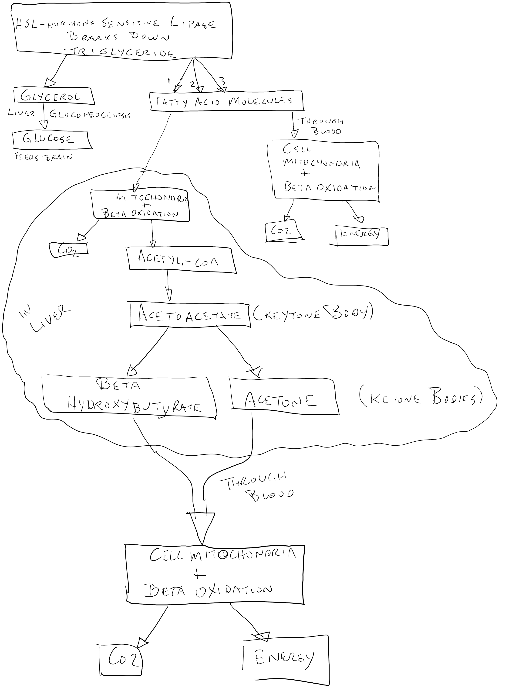
- you don’t get enough protein for a day, a week or a month, your body will allow net breakdown of some tissues in order to recycle the amino acids it needs to keep vital structures up to par.
- guidelines recommend 0.8 grams/day of protein per kilogram of body weight for adults, withRead more at location 1085
- Put another way, when you first take away dietary carbs, you need more protein to maintain muscle and other protein-containingRead more at location 1095
- once you are keto-adapted, your body’s need for protein isn’t much higher than during a ‘balanced diet’.Read more at location 1097
- All the protein we eat (with the exception of stuff that is rubbed or cut off, like skin, hair, and nails) eventually gets burned for energy, yielding 4 Calories per gram. And you can’t “push” your body to build muscle by eating extra protein – muscle is built up under the stimulus of exerciseRead more at location 1100
- No one has ever shown that more than 1.5 gram/kg improves human protein synthesisRead more at location 1102
- power athletes have made the empiric observation that they train and compete better on proportionately higher protein intakes (e.g., 1.5 to 2.5 grams per kg).Read more at location 1104
- As a general rule, in the short term, people start to feel “unwell“ if they routinely eat more than 30% of their daily energy need as protein.Read more at location 1106
- “protein foods” like bacon, eggs, fried chicken, tuna salad, hamburger, and even lean steak typically contain more fat calories than protein calories. So in fact, “high protein” diets consisting of common foods tend to be higher in fat than protein.Read more at location 1108
- when a person makes the transition from weight loss to weight maintenance on a low carbohydrate diet, total energy intake must increase.Read more at location 1117
- Most fats we get from foods are triglycerides, consisting of a glycerol “backbone” with 3 fatty acid molecules attached. An additional class of dietary fat, coming from the membranes of plants and animal, is phospholipids, which tend to be higher in essential fatty acids. Both triglycerides and phospholipids can be metabolized (burned) for energy, and they provide about 9 Calories per gram.Read more at location 1137
- Because fats do not dissolve in water, they are carried in the bloodstream as triglyceride droplets surrounded by emulsifying molecules like phospholipids, cholesterol, and proteins. These particles are called lipoproteins, and they are subject to much loathing because they contain cholesterol. In reality, these lipoproteins are like trucks loaded with energy traveling about in the bloodstream delivering fuel to cells.Read more at location 1142
- In another similarity to glucose, fat is also taken up by muscles for both immediate use as well as for storage. Fat storage droplets in muscle serve as reserve fuel to support exercise (just like glycogen), dropping to low levels after prolonged exercise and building back up over the next day or two of recovery.Read more at location 1150
- In addition to their role as the body’s primary fuel source when insulin levels are restrained, dietary fats also contain two ‘families’ of essential fatty acids. Identified by their uniquely positioned double (unsaturated) bonds called omega-3 and omega-6,Read more at location 1153
- And because their unique structures cannot be created by human metabolism, these two classes of essential fats must be consumed from dietary sources.Read more at location 1155
- Healthy normal men can have up to 20% body fat, whereas this upper limit for women is 28%.Read more at location 1163
- it is not unusual to find highly trained males with less than 10% body fat (and similarly under 15% in female athletes).Read more at location 1165
- The other variable with body fat is where it is located. Fat carried “centrally” (i.e., around the middle, and particularly within the abdominal cavity) is associated with greater risk for developing diabetes and heart disease than fat carried below the waist.Read more at location 1168
- Sitting quietly in the boat (i.e., not rowing) she’ll start out burning about 2000 Calories per day.Read more at location 1180
- At rest, skeletal muscles prefer fat for fuel, using glucose only when insulin levels are high and blood sugar needs some place to go. During sustained exercise, fat is still the preferred fuel at intensities up to 50-60% of that muscle’s maximum continuous effort.Read more at location 1202
- Above 60% of maximum effort, glucose (or stored glycogen) progressively assumes a dominant role, although this dominance is attenuated when individuals are given a few weeks to adapt to a low carbohydrate diet[23, 27]. Also at these higher intensities, some of this glucose is not completely metabolized but is partially broken down to lactate and released back into the bloodstream rather than being oxidized in muscle mitochondria all the way to CO2 and water.Read more at location 1204
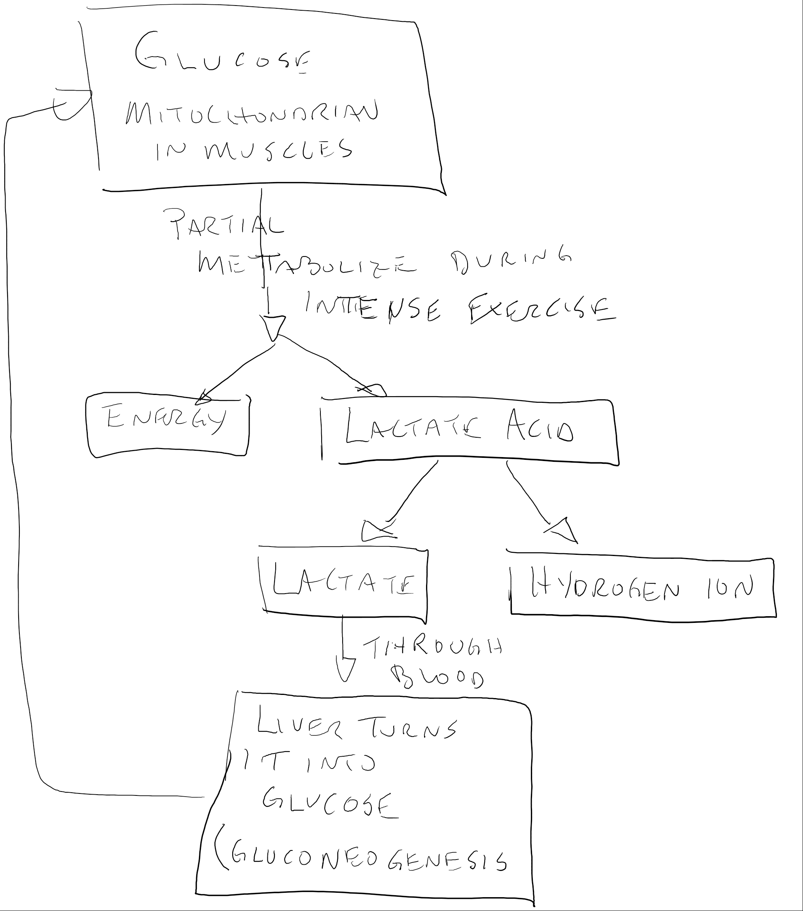
- Lactate has a bad reputation as a cause of muscle fatigue and pain. This is a classic case of guilt by association. During transition from rest to intense exercise, the increased production of lactic acid rapidly disassociates into lactate and hydrogen ion. It is the accumulation of hydrogen ion, not lactate per se, that contributes to fatigue due to acidosis.Read more at location 1209
- Much of the lactate released from muscle during exercise gets taken up by the liver and made back into glucose (a process called gluconeogenesis) and sent back to the muscles where it can be made into lactate again. And because the liver uses mostly fat to power gluconeogenesis, this shuttle of glucose out from the liver and lactate back (called the Cori cycle) actually ends up powering resistance exercise from energy released by fat oxidation in the liver.Read more at location 1212
- Heart: The predominant fuel preferred by your heart when you are not exercising is fat. The heart rarely uses much glucose, with the only exception being during a heart attack when a vessel is plugged and the oxygen supply to that part of the muscle is cut off or severely reduced.Read more at location 1216
- During exercise, a healthy and well-perfused heart actually takes up lactate from the circulation and burns it to CO2 and water.Read more at location 1219
- Lactate is preferred by heart muscle cells over glucose, and during endurance exercise, lactate can provide as much as 50% of your heart’s energy need[28].Read more at location 1220
- Liver: The liver does a whole lot of important things for the rest of the body, such as making, storing, and releasing glucose when necessary, making ketones when carbohydrate intake is restricted for more than a few days, collecting and secreting fats and lipids as lipoproteins, and making and secreting a number of important blood proteins. As a result, the liver uses a lot of energy for an organ its size, and most of the energy it uses comes from fat. The liver can get the fat it needs from circulating fatty acids released from fat cells, from remnant lipoproteins it removes from the circulation, or by making fat from carbohydrates (lipogenesis).Read more at location 1222
- Brain: The brain is the spoiled child of the organ family. It can burn glucose or ketones (or a combination of the two) and it can’t burn fat.Read more at location 1227
- Another surprise about the brain is how much energy it consumes each day (600 kcal) despite weighing just 3 pounds. This is more than 10-times the average energy use per pound of the rest of the body,Read more at location 1230
- liver ketone production does not kick in until daily carbohydrate intake is consistently at or under 50 grams (200 kcal) per day for a number of days.
- Well, this illustrates that the keto-adapted state allows your body more flexibility in meeting its critical organ energy needs than a ‘balanced’ but energy-restricted diet. And in particular, this also means that your brain is a “carbohydrate dependent organ” (as claimed by the USDA Dietary Guidelines Advisory Committee as noted in Chapter 3) ONLY when you are eating a high carbohydrate diet.Read more at location 1263
- And because exercise stimulates ketone production, your brain’s fuel supply is better supported during and after intense exercise when on a low carbohydrate diet than when your carbohydrate intake is high (see below).Read more at location 1267
- Above 43 liters, the kidneys speed their function and clear the excess fluid, whereas below 41 liters, thirst prompts us to increase our water intake. The result is that most people’s weight varies randomly across a range equivalent to 2 liters of water – about 4 pounds.Read more at location 1333

Chapter 7 INSULIN RESISTANCERead more at location 1358

- insulin binds to a receptor at the muscle cell surface, allowing glucose to be transported across the cell membrane to be used for energy or to replace depleted glycogen levels. Read more at location 1365
- The primary reason we have an entire chapter about insulin resistance is that well-formulated low carbohydrate diets consistently make it better.Read more at location 1381
- The primary stimulator of insulin release from the pancreas is dietary carbohydrate. In contrast, an equal amount of dietary energy as fat has virtually no effect on insulin levels.Read more at location 1410
- A low carbohydrate diet switches the body’s fuel use to primarily fat. WithRead more at location 1420
- Insulin Resistance is a Hallmark of Metabolic Syndrome and Type-2 DiabetesRead more at location 1438
- These patients need insulin injections not just to control blood glucose levels, but also to regulate the release of fats from fat cells. When fat cells release fatty acids too rapidly, ketone production becomes imbalanced and this leads to diabetic ketoacidosis.Read more at location 1449
- By contrast, in most type-2 diabetics, the pancreas produces more than normal amounts of insulin because the muscle cells (which account for most of our bodies’ insulin-stimulated glucose clearance) have become resistant to its signal.Read more at location 1454
- Inflammation causes our cells (specifically our mitochondria) to increase production of molecules called ‘free radicals’. Free radicals are like mini roadside bombs that interfere with normal cellular functions. Read more at location 1485
- So here are the dots we think can be connected: 1) dietary carbohydrate raises serum insulin; 2) insulin promotes inflammation in susceptible people; 3) inflammation increases cellular free radical generation; 4) free radicals attack any convenient nearby target; 5) ideal targets for free radicals are membrane polyunsaturated fats; 6) membrane polyunsaturated fats are important determinants of cellular function such as insulin sensitivity.Read more at location 1487
- Low Carb Diets Reduce Inflammation In the above study of people with metabolic syndrome[29], we also did a panel of tests for biomarkers of inflammation. And despite the relatively small size of the study group and the notorious variability of these biomarkers, every one of the 16 indicators of inflammation went down in the group on the low carbohydrate diet.Read more at location 1524
- Inflammation predicts the subsequent development of metabolic syndrome and type-2 diabetes, and inflammation is the biologic enemy of the highly unsaturated fatty acids found in cell membranes. Reduced levels of these membrane HUFAs are associated with insulin resistance, and a low carbohydrate diet simultaneously corrects the membrane HUFA deficit, improves insulin sensitivity, and reduces the body’s level of inflammation.Read more at location 1587

Chapter 8 LIPOPROTEIN EFFECTSRead more at location 1596

- The majority of cholesterol circulates in our bloodstream as ‘low density lipoprotein cholesterol’ (LDL-C), making it the prime target of drug and lifestyle strategies to prevent heart disease.Read more at location 1602
- Taken as a whole, dietary strategies to lower LDL-C have consistently failed to impact incidence of heart disease.Read more at location 1609
- lipoproteins are spherical particles that consist of varying amounts of lipids (fat substances like cholesterol, triglycerides, phospholipids) and proteins. The lipid soluble parts are packaged in the core, whereas the water-soluble components face the periphery, thereby allowing lipoproteins to travel through the aqueous serum of the bloodstream delivering lipid cargo to and from cells.Read more at location 1614
- LDL-C (and its precursor very-low density-lipoprotein cholesterol) delivers cholesterol and other lipid substances from the liver to other organs throughout the body, whereas high-density lipoprotein (HDL-C) carries lipids in the opposite direction back to the liver for disposal. Too much cholesterol circulating as LDL-C may lead to accumulation of cholesterol in the arterial wall, plaque formation, and arterial disease. Read more at location 1617
- the presumed causal link between ‘total’ LDL-C and heart disease is tenuous.Read more at location 1638
- In 1994, the Lyon Diet Heart Study [48] was terminated prematurely at 27 months due to a dramatic decrease in mortality in the group that consumed a 40% fat Mediterranean-type diet compared to a group that was prescribed the American Heart Association’s ‘prudent diet’. Read more at location 1641
- low carbohydrate diets consistently and significantly increase LDL particle size irrespective of the response in LDL-C concentration. Compelling data now indicate that having more small LDL particles is associated with increased risk for heart disease[50].Read more at location 1651
- A small to moderate increase in one’s total LDL-C is not worrisome if other lipid and inflammatory markers are dramatically improved in response to reducing dietary carbs. If, for example, your serum triglycerides went way down on a low carbohydrate diet (which they almost always do) then chances are you have also decreased the smaller more dangerous LDL particles even if your total LDL-C concentration increased.Read more at location 1657
- LDL-C is calculated as total cholesterol minus the sum of HDL-C and VLDL-C. LDL-C = Total Cholesterol – [HDL-C + (Triglycerides/5)] A major assumption is that the ratio of triglyceride to cholesterol is constant. VLDL is estimated as equal to triglycerides (mg/dL) divided by 5. This presumed 5:1 ratio is not constant, and the errors from this LDL-C calculation are significant[52].Read more at location 1667
- Most people now have the ‘LDL-C is bad and HDL-C is good’ concept down pat. But there is more to the story. It is well established that not all LDL particles are created equal.Read more at location 1708
- As noted previously, the larger more buoyant LDL particles are less harmful than smaller ones. Small LDL particles reside in the circulation longer, have greater susceptibility to oxidative damage by free radicals, and more easily penetrate the arterial wall, contributing to atherosclerosis.Read more at location 1710
- No matter what your total LDL-C concentration, if you have relatively more small particles (referred to as Pattern B) it puts you at a several-fold higher risk for heart disease compared to people with larger LDL particlesRead more at location 1712
- And a recent study with a statin (the JUPITER Study) indicates that much of the benefit with this class of drug is due to reduced inflammation rather than reduced LDL-C[46]. Therefore, if a diet could reduce your level of inflammation (discussed in Chapter 14), perhaps there’s less need for the drug.Read more at location 1726
- An increase in fasting triglyceride levels is an early signal that your body is struggling to metabolize carbohydrate. Therefore the weapon of choice for managing elevated triglyceride levels is carbohydrate restriction.Read more at location 1770
- In addition to this limited capacity to store carbohydrate in the body, the metabolic conversion of glucose to glycogen (glycogen synthesis) is relatively slow, and in particular it is markedly impaired in individuals with insulin resistance. How then does a person with insulin resistance deal with a high carbohydrate meal? Whereas the conversion of glucose to glycogen is self-limiting, there is an almost infinite capacity to convert carbohydrate to fat (aka, de novo lipogenesis). The fatty acids derived from carbohydrate-induced hepatic de novo lipogenesis are made into triglycerides, packaged into large VLDL particles, which are then released into the circulation, contributing to elevated plasma triglycerides.Read more at location 1776
- Dietary carbohydrate restriction increases the prevalence of larger LDL particles, whereas low fat/high carbohydrate diets have the opposite (and overtly harmful) effect.Read more at location 1786
- As people move down the carbohydrate ladder, more and more of them convert their serum lipids from pattern B to Pattern A and thus decrease their cardiovascular risk.Read more at location 1788
- The truth is that saturated fats only become problematic when they accumulate. And the guilty party for saturated fat accumulation, in most cases, is dietary carbohydrate.Read more at location 1807
- HDL-C is one of the best biomarkers of long term cardiovascular health.Read more at location 1820
- The importance of HDL-C derives from its well established role as a scavenger of excess unesterified cholesterol from lipoproteins and tissues requiring transport back to the liverRead more at location 1822
- HDL-C also increases bioavailability of nitric oxide (important to the regulation of vascular function and blood pressure) and has antioxidant, anti-inflammatory, anti-thrombotic, and anti-apoptotic effects, all of which contribute to its antiatherogenic properties. Read more at location 1824
- low carbohydrate diets increase HDL-C[47]. The increase in HDL-C may not occur as quickly as the decrease in triglyceride, but based on empirical evidence and the results of a recent 2 year diet study[66], this slowly developing HDL-C boost appears to be very resilient.Read more at location 1827
- Studies indicate the triglyceride/HDL-C ratio is highly associated with insulin resistance[55]. Simply put, the higher your triglycerides and/or the lower your HDL-C, the greater your degree of insulin resistance.Read more at location 1871
- A TG/HDL ratio 33.5 has been suggested as a cutoff for identifying the insulin-resistant patient most at risk for cardiovascular disease[55].Read more at location 1876
- And how best to improve your triglyceride/HDL ratio? The striking reductions in plasma triglycerides and consistent increases in HDL-C in response to low carbohydrate diets are unparalleled by any other lifestyle intervention, or even drug treatment, and therefore represents the most powerful method to improve this ratio.Read more at location 1884
- Chemically, a triglyceride is composed of 3 molecules of fatty acids bound to a glycerol backbone. Triglyceride is the major type of fat ingested and stored in the body. Read more at location 1890
- Triglycerides are also made in the liver and packaged into lipoproteins called very low density lipoproteins (VLDL) that are released into the plasma. Chylomicrons and VLDL therefore constitute the triglyceride-rich lipoproteins.Read more at location 1892
- intestine synthesizes an abbreviated version apo-B-48 that associates with chylomicrons. The triglycerides in chylomicrons and VLDL are hydrolyzed by lipoprotein lipase (LPL) located in the capillary walls of various tissues, primarily skeletal muscle and adipose tissue. The primary functions of LPL are to clear triglycerides from the circulation and augment the supply of free fatty acids to various tissues such as skeletal muscle, adipose tissues, and heart for either storage or oxidation.Read more at location 1894

Chapter 9 EFFECTS OF CARBOHYDRATE RESTRICTION ON FATTY ACID METABOLISM Read more at location 1905

- Part of the human body’s adaptation to carbohydrate restriction involves fundamental changes in how it metabolizes fatty acids.Read more at location 1907
- Not only does total fat oxidation increase, but the body’s rate of saturated fat oxidation accelerates more than other types of fatty acids, driving down levels of saturated fat in the blood. Also, the body literally stops making fat out of carbohydrate (i.e., de novo lipogenesis), much of which ends up as saturated fats in the blood. Understanding that this happens and why opens an important door to our understanding of how a high fat diet, even one containing a lot of saturated fat, can still be healthy. Read more at location 1910
- Polyunsaturates are obligate components of phospholipids, which in turn are needed to construct the membranes that enclose our cells and regulate cellular functions. Getting the right amount of polyunsaturated fats into membranes is critical for life-defining processes such as glucose transport (i.e., insulin sensitivity), controlling inflammation, salt excretion, blood pressure control, egg release from ovarian follicles, and sperm motility. Read more at location 1915
- Thus the mix of fats found in membrane phospholipids is dramatically different from that found in the triglycerides stored in adipose tissue.Read more at location 1930
- There are 3 types of fats commonly found in our diet:
- Saturated fat – see this article for details https://draxe.com/the-truth-about-saturated-fat/
- Monounsaturated fat – MUFAs – (can be obtained from Olives, Extra virgin olive oil, Avocados, Almonds, Peanuts, Cashews, Tea seed oil, Eggs, Red meat) See info graphics below from https://draxe.com/monounsaturated-fat/
- Polyunsaturated fat – PUFAs -
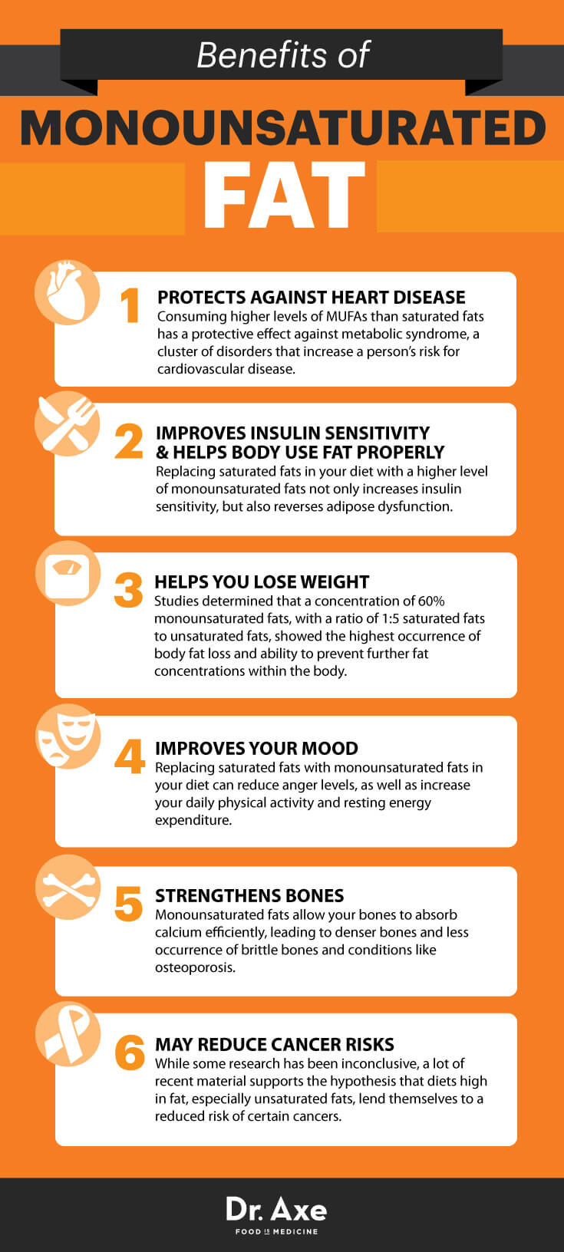

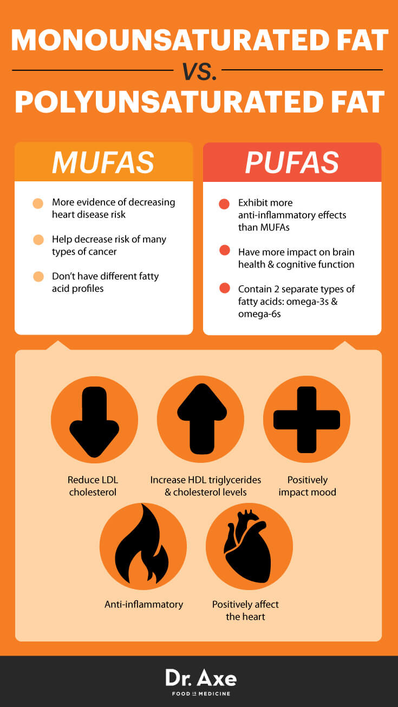

- A fourth type of fat, trans fat, is a manufactured fat and must be avoided in our diets at all costs.

- There are three things we can do with saturated fats obtained from, or produced as a result of, our diet:
- burn them
- store them
- or make them into something else (e.g., a mono-unsaturate).
- Insulin, which goes up in the blood when we eat carbohydrates, turns off fat oxidation and stimulates fat storage. And when we stop eating lots of carbs and our insulin levels fall, the opposite happens; fats come out of storage and become the body’s primary fuel. Read more at location 1935
- the low fat diet group was 12 grams per day, while the low carbohydrate group was eating 36 grams per day – three times as much. In the serum samples done at baseline and again after 12 weeks, serum triglycerides in the low fat group went from 187 to 151 mg per 100 ml, a tidy 19% reduction. But in the low carb group, the before and after values were 211 and 104, a whopping 51% fall. Both visually (just looking at the numbers) and statistically, the low carbohydrate group had a much greater (better) reduction in serum triglycerides.Read more at location 1946
- As a proportion of the total, the low carb group had 33% saturates at baseline and 29% after 12 weeks, whereas the low fat group started at 30 and ended at 29%. So after 12 weeks of dieting, the proportion of saturated fats in the blood triglycerides was the same for both groups despite the fact that the low carb group was eating three times as many grams per day of saturated fat in their diet.Read more at location 1951
- Because the low carb group ended up with blood triglycerides of 104 mg per 100 ml compared to the low fat group’s 151, they actually had about 30% less total triglycerides circulating in their serum. So although the two groups had similar relative proportions of saturates, this means that the absolute serum content of saturates in the low carb group was 30% lower than the low fat diet group. So what we found, in a nutshell, is that despite a higher intake of saturated fat, the proportionate blood level of saturated fats did not increase, and their absolute levels fell dramatically with the low carbohydrate diet.Read more at location 1955
- The bottom line on this point is that when our metabolism adapts to a low carbohydrate diet, saturated fats become a preferred fuel for the body, and their levels in blood and tissue triglyceride pools actually drop.Read more at location 1967
- know about POA, and is it really important enough to justify struggling through all this detail? Well, it has been observed that serum POA predicts the subsequent development of type-2 diabetes.Read more at location 2009
- As we noted above, POA predicts insulin resistance and type 2 diabetes. Reducing carbohydrate reduces serum POA levels.Read more at location 2019
- POA is a sensitive (and powerful) biomarker of carbohydrate intolerance.Read more at location 2023
- polyunsaturated fatty acid (PUFA)Read more at location 2030
- group of molecules we call free-radicals (or more precisely, reactive oxygen species – ROS),Read more at location 2050
- Inflammation driven by the forced metabolism of carbohydrate drives up the production of ROS in mitochondria. ROS damage membrane EFA end-products, which at some point can’t be replaced fast enough.Read more at location 2054

Chapter 10 BODY COMPOSITION AND PHYSICAL PERFORMANCE Read more at location 2133

- In addition, there is a growing appreciation that increased muscle mass contributes to metabolic health.Read more at location 2146
- More muscle translates to greater tissue volume to take up blood glucose and more mitochondria that can burn fat. That helps fend off insulin resistance and diabetes.Read more at location 2147
- fact, properly formulated ketogenic diets have a remarkable capacity to protect muscle and exercise performance during periods of caloric restriction.Read more at location 2196
- Volek reported that normal-weight men who switched from their habitual diet (48% carbohydrate) to a ketogenic diet (12% carbohydrate) for 6 weeks significantly decreased fat mass (-3.4 kg) and increased lean body mass (1.1 kg)[79]. There was a significant decrease in serum insulin (-34%) and simple regression indicated that 70% of the variability in fat loss on the ketogenic diet was explained by the decrease in serum insulin concentrations.Read more at location 2222
- Resistance training does not affect fat loss to a great extent independent of diet. However, muscular overload induced by resistance exercise creates an anabolic stimulus for skeletal muscle fiber hypertrophy.Read more at location 2240
- Many studies have been conducted in the context of low fat diets and generally indicate that resistance exercise (2-3 days/week) can preserve lean body mass during weight loss.Read more at location 2242
- But the combination of dietary energy restriction with resistance training resulted in better maintenance of lean tissue during weight loss.Read more at location 2247
- Thus, when more recent studies using longer periods of diet adaptation to a low carbohydrate intake were done, the apparent advantages of a high carbohydrate diet were not observed[23, 76].Read more at location 2314
- In these longer duration studies, when carbohydrate was kept low, with or without energy restriction, we observed no loss of peak aerobic power (VO2max) or peak muscle strength[87].Read more at location 2316
- But BMI can overestimate body fatness in people with a lot of muscle and large frames.Read more at location 2328

Chapter 11 PERSONALIZED NUTRITIONRead more at location 2354

- Nutrients are broadly classified into 4 macronutrient categories that provide energy
- carbohydrate
- fat
- protein
- alcohol
- (Dr. Dom D’Augustino says Ketones bodies may be another macro nutirent)
- We also need a regular source of several essential micronutrients (vitamins, minerals) that our body cannot make and we therefore must obtain from food.Read more at location 2415
- The genome consists of over 3 billion base pairs made up of long chains of adenine, guanine, cytosine and thymine on the 23 chromosomes. Humans have about 21,000 genes, each encoding a protein, scattered around the genome. The length of DNA that contains a typical gene extends about 50,000 base pairs, of which only a fraction, say 1,000—actually encode the protein sequence. This means the majority of the genome (~98%) consists of expanses of DNA whose function(s) remain unknown.Read more at location 2427
- Depending on dose and timing of dietary carbohydrate, blood glucose can exhibit large and rapid excursions.Read more at location 2455
- While the time required for adaptation may vary, and it certainly takes at least 2 weeks, the end result of this adaptation is the same. StarvationRead more at location 2474
- we are hardwired to respond to carbohydrate restriction in a reliable and ‘healthy’ manner.Read more at location 2477
- We have already explained that insulin resistance, metabolic syndrome, and type 2 diabetes are all manifestations of carbohydrate intolerance.Read more at location 2491
- genetics probably accounts for 50-80% of the variability in BMI.Read more at location 2497
- Complex diseases like type 2 diabetes are not due to a single gene, they are polygenetic (i.e., diseases that depend on the simultaneous presence of several genes).Read more at location 2500
- If you have carbohydrate intolerance, metabolically this translates to a propensity to divert dietary carbohydrate away from skeletal muscle and towards the liver. And if liver glycogen stores are full, a significant portion of your additional dietary carbohydrates will be converted to fat.Read more at location 2525

Chapter 12 LOW CARBOHYDRATE RESEARCH PITFALLSRead more at location 2560

- No notes

Chapter 13 CLINICAL USE OF CARBOHYDRATE RESTRICTION: VERY LOW CALORIE AND LOW CARBOHYDRATE DIETSRead more at location 2805

- Dr. Robert Atkins promoted a less energy-restricted approach to a ketogenic diet. His focus was on keeping carbohydrate intake low enough to induce ketosis, but not to severely limit (or even count) calories.Read more at location 2820
- It was his view that this diet, including vegetables, limited fruit, and vitamin supplements, could be followed by the individual outpatient without close medical supervision unless there was a pre-existing complicating condition like diabetes or hypertension.Read more at location 2822
- Steve Phinney’s bike racers produced the same power output in testing on a stationary bike using the same oxygen consumption after adapting to the Inuit diet compared to their test on a high carb diet[23], leaving little room for metabolic inefficiency in this group of subjects.Read more at location 2832
- If dietary carbohydrate intolerance led to the choice of a low carbohydrate diet at the outset, why lift that restriction? In particular, why add back calories that promote fat storage but do not provide functional satiety? Accepting that protein is good for us only in moderation, the answer is fat (see Chapters 2 and 16). How much fat should you add as you approach weight maintenance? The simple answer: “let satiety rule”.Read more at location 2848
- nutritional ketosis is defined by serum ketones ranging from 0.5 up to 5 mM, depending on the amounts of dietary carbohydrate and protein consumed. In most people, the combined intake of 100 grams of carbohydrate and 100 grams of protein will drive serum ketones well below 0.5 mM. While there is nothing magical about having circulating ketones above this threshold level, it does have the practical value of providing the brain with a virtually limitless, fat-derived fuel source. This alternative fuel is eminently more sustainable, particularly in the insulin resistant or carbohydrate intolerant individual.Read more at location 2853
- Meanwhile, the body is undergoing a complex set of adaptations in ketone metabolism[99]. Beta-hydroxybutyrate and acetoacetate are made in the liver in about equal proportions, and both are initially promptly oxidized by muscle. But over a matter of weeks, the muscles stop using these ketones for fuel. Instead, muscle cells take up acetoacetate, reduce it to betahydroxybutyrate, and return it back into the circulation. Thus after a few weeks, the predominant form in the circulation is beta-hydroxybutyrate, which also happens to be the ketone preferred by brain cells (as an aside, the strips that test for ketones in the urine detect the presence of acetoacetate, not beta-hydroxybutyrate). The result of this process of ketoadaptation is an elegantly choreographed shuttle of fuel from fat cells to liver to muscle to brain.Read more at location 2862
- A number of businesses have developed prototype handheld devices to measure breath acetone, but at the time of this writing, nothing practical is on the market.Read more at location 2877
- Because of the greater intake of vegetables and total energy, a less restricted low carbohydrate diet such as Atkins raises fewer concerns in an otherwise healthy patient.Read more at location 2888
- In the vast majority of patients, this rise in serum uric acid is completely benign and requires no intervention. In the minority of individuals predisposed to gout, however, wide swings in uric acid can trigger an attack.Read more at location 2902
- weight-related condition, you need a physician (other than your mirror) monitoring your progress. If your personal physician isn’t experienced in the use of low carbohydrate diets, Jimmy Moore (Chapter 21) has a service to help you find one who is, or you can just give your physician a copy of this book.Read more at location 2960

Chapter 14 METABOLIC SYNDROMERead more at location 2991

- approximately 64 million or 34% of adults with metabolic syndrome in the United States[103].Read more at location 2994
- metabolic syndrome describes a collection of metabolic abnormalities. These derangements in combination are a harbinger of type 2 diabetes and cardiovascular disease.Read more at location 3006
- Dietary carbohydrate is a direct source of blood glucose. Therefore restriction in dietary carbohydrate intuitively leads to fewer fluctuations in blood glucose. Ingesting carbohydrate, especially rapidly digested forms, stimulates a rapid increase in insulin from the pancreas.Read more at location 3242
- The culprit is our excessive intake of insulin-stimulatory dietary carbohydrates, especially simple sugars and refined starches.Read more at location 3290

Chapter 15 TREATING TYPE-2 DIABETES AS CARBOHYDRATE INTOLERANCE Read more at location 3294

- No notes

Chapter 16 THE IMPORTANCE OF DIETARY FAT IN LONG-TERM MAINTENANCE Read more at location 3514

- As indicated in the graph on the next page,Read more at location 3545

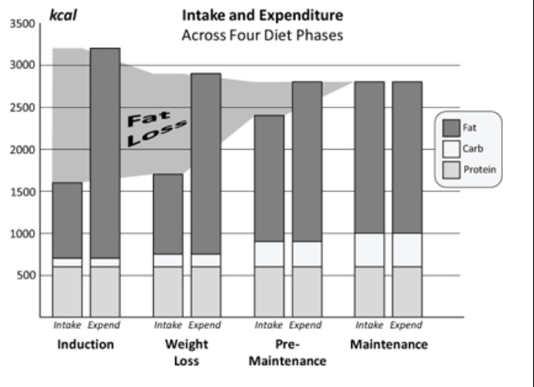

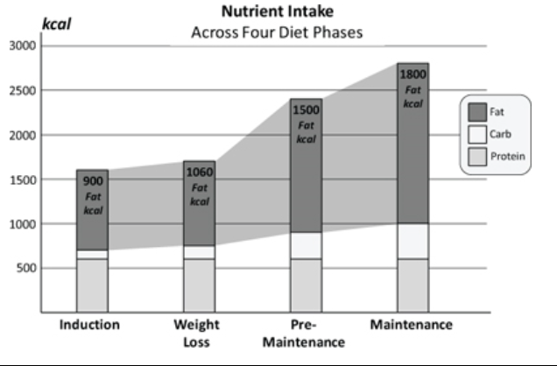

- When he reaches his maintenance weight and is eating 2800 kcal/day, there is neither need nor reason for him to increase his protein intake above 150 grams, which now calculates out as 21% of his total intake. Let’s also assume that he has pretty good carbohydrate tolerance, allowing him to increase that to 100 grams (400 kcal) per day. However the remainder of his daily energy intake (which now must match his expenditure) has to come from dietary fat – 1800 kcal or 200 grams per day.Read more at location 3556
- The answer to this conundrum is that our subject (and perhaps you as well) needs to make his peace with eating fat as his primary maintenance fuel. This is not a radical concept anymore. We have demonstrated how it can be safe and provide a ready and sustained fuel supply to all parts of the body. His 1800 kcal per day intake of fat is 65% of his total calories. Rest assured that an adult male can easily oxidize this amount of fat over a 24 hour period. Using indirect calorimetry in subjects adapted to low carb diets, we typically see average respiratory quotient (RQ) values well below 0.8 (even during moderate intensity endurance exercise), and this is consistent with someone burning less than 100 grams of total carbs per day, with most of the rest coming from fat.Read more at location 3604
- Example: Daily caloric intake and expenditure in a 5’6” woman losing from 180 to 140 lbs. Assumes 30 kcal/kg before and 35 kcal/kg after weight loss.Read more at location 3616

Chapter 17 THE JOY OF COOKING (AND EATING) FATRead more at location 3671

- Most of the fat in prepared mayonnaise, dressings, sauces, and marinades is the wrong kind for a person on a high fat diet – high in polyunsaturated fat (PUFA) from the cheap, government subsidized soy, corn, and cottonseed oils used as ingredients.Read more at location 3689
- High Fat Side Dishes Sautéed kale with garlic and olive oilRead more at location 3708
- Cucumber yogurt saladRead more at location 3731
- French Fried Green BeansRead more at location 3765
- WedgieRead more at location 3809
- High Fat, Moderate Protein, Low Carb Breakfast SmoothiesRead more at location 3827
- Shop until you find unflavored whey powder with the lactose removed – the label should indicate about 15 grams of protein and less than one gram of carbohydrate per serving. Do not buy soy protein powder or whey/soy mix, as the soy does not dissolve well into the smoothie.Read more at location 3833
- Breakfast Berry Smoothie Ingredients: 3 oz fresh or frozen (unsweetened) berries (strawberries, blueberries, or raspberries) ¼ cup whipping (or heavy) cream 1 tablespoon light olive oil 2 tablespoons unflavored whey protein powder (delactosed) sweetener of choice (e.g., 1 tablespoon xylitol and 1 packet Splenda) 2-3 oz ice Blend the ingredients at high speed until smooth (30-60 seconds) Protein 15 grams, Fat 25-30 grams, Carbs 10 grams, Calories 330-380Read more at location 3837
- Day 1 in the Low Carb Life Breakfast berry smoothie (low carb, high fat) Lunch 2 cups mixed greens 6 oz water pack tuna 10 black olives ½ cup blue cheese dressing (yogurt, olive oil) Snacks 2 oz mixed nuts, broth 2 oz soft cheese with 6 oz celery Dinner 8 oz tomato bisque 8 oz steak 4 oz buttered green beans 4 oz sauteed mushrooms 4 oz maple walnut ice cream (made w/ sucralose/xylitol) Total: 2100 kcal fat, 600 protein, 150 carbs (74% fat, 5% carb, 21% protein)Read more at location 3974
- Day 2 Breakfast 2 eggs 2 slices bacon ½cup sauteed mushrooms Lunch 1 cup beef broth 6 oz cold roast pork lettuce wedge 2 oz honey basil dressing Snacks 2 oz mixed nuts, broth 2 oz cheddar cheese Dinner 6 oz roast chicken with fennel kale sauteed with bacon, garlic, and olive oil 4 oz berries with cream Total: 1800 kcal fat, 520 protein, 130 carbs (73% fat, 5% carb, 22% protein) Day 3 Breakfast black coffee cauliflower corned-beef hash with peppers and onions (1 tbs olive oil) Lunch Chicken Caesar salad (takeout, 4 oz chicken) ½ packet commercial Caesar dressing (made with soybean oil) 1 tablespoon olive oil unsweetened iced tea Snacks 2 oz mixed nuts, broth 2 oz soft cheese with 6 oz celery Dinner 8 oz sorrel soup 8 oz baby back pork ribs lettuce wedge (8 oz) 2 oz yogurt/blue cheese dressing 1 oz bacon bits 1 oz blue cheese crumbles 2 oz chopped tomatoes 2 oz chopped cucumber Total: 1880 kcal fat, 490 protein, 120 carbs (76% fat, 5% carb, 19% protein) Day 4 Breakfast 2-egg omelet (1 oz each bacon, mushrooms, cheese, tomato) black coffee Lunch 2 cups Cobb salad (takeout) 1 tablespoon olive oil Unsweetened iced tea Snacks 2 oz mixed nuts, broth 10 black olives stuffed with ripe brie cheese Dinner 8 oz French onion soup (with 2 oz guerre cheese and 2 oz onion) Sole stuffed with creamed spinach in cheese sauce Blueberry cheese cake Total: 1600 kcal fat, 440 protein, 120 carbs (74 % fat, 6% carb, 20% protein)Read more at location 3994
- Day 5 Breakfast black coffee 3 oz smoked salmon 1 oz creamed cheese 1 tbsp capers 6 lettuce leaf wrappers Lunch 2 cups mixed greens 6 oz water pack tuna 10 black olives ½ cup blue cheese dressing (yogurt, olive oil) Snacks 2 oz mixed nuts, broth 2 oz soft cheese with 6 oz celery Dinner 12 oz low carb sausage chili 8 oz grilled asparagus with herb butter 4 oz cocoa pecan ice cream Total: 1810 kcal fat, 530 protein, 200 carbs (71 % fat, 8% carb, 21% protein)Read more at location 4049
- Day 6 Breakfast black coffee 4 oz ham slices wrapped around 4 oz cold grilled buttered asparagus Lunch Double bacon cheeseburger (no bun) Unsweetened iced tea Snacks 2 oz mixed nuts, broth 4 oz diced cucumber, 2 oz diced tomato 2 oz yogurt blue cheese dressing Dinner 8 oz bacon wrapped steak 4 oz french-fried green beans 4 oz sauteed mushrooms 4 oz maple walnut ice cream (made w/ sucralose/xylitol) Total: 1755 kcal fat, 564 protein, 132 carbs (72% fat, 5% carb, 23% protein)Read more at location 4069
- Day 7 Breakfast mocca freeze smoothie Lunch 2 cups mixed greens 6 oz water pack tuna 10 black olives ½ cup blue cheese dressing (yogurt, olive oil) Snacks 2 oz mixed nuts, broth 2 oz soft cheese with 6 oz celery Dinner Coq au vin (stewed chicken) 4 oz tomato 4 oz sauteed mushrooms 2 oz onion lettuce wedge with honey basil dressing Total: 1727 kcal fat, 520 protein, 224 carbs (70% fat, 9 % carb, 21% protein)Read more at location 4085
- There is so much omega-6 fat in our food supply that if 60% or more of your daily energy is coming from fat, it’s highly unlikely you’d ever come up short. As for the omega-3’s, either 3 fish meals per week or a gram of supplemental fish oil daily suffices.Read more at location 4156
- we give high priority to mono-unsaturates, then saturates, and make reasonable efforts to avoid rich sources of omega-6 polyunsaturates. Read labels and select foods containing olive, high-oleic safflower, and canola oils. Use olive oil or high-oleic safflower in cooking. Butter and full-fat cheese are OK, Read more at location 4162
- When possible, avoid mayonnaise and dressings made with soybean, corn, sunflower, and cottonseed oils.Read more at location 4164
- Take 3 slow-release magnesium tablets daily for 20 days. The proprietary brand-name product is ‘Slow-Mag’®, but there are a number of equally effective generics at a fraction of the brand-name price (e.g., Mag-64® or Mag-Delay®). Most people’s cramps cease within 2 weeks of starting ‘Slow-Mag®’, but you should continue to take the full 20-day course (60 tabs per bottle at 3 per day lasts 20 days). If the cramps return, do it again, and then continue taking one tab per day. If the cramps return, take 2 tabs per day. Most people can be titrated to remain crampfree by this method. Why use a more expensive slow-release magnesium preparation like Slow-Mag®? Because magnesium oxide preparations like ‘milk of magnesia’ cause diarrhea, passing through the small bowel before they can be effectively absorbed.Read more at location 4230
- Does your patient have excessive hunger, a preoccupation with food even after eating, and an inability to control the intake of carbohydrate foods? Are symptoms relieved, at least temporarily, by eating? These are common experiences for people who are carbohydrate intolerant or addicted.Read more at location 4482
- Common symptoms of unstable blood sugar can include any of the following. • Mood and/or energy swings that can occur several times during the day. These can be triggers to overeat or get a quick fix from a candy bar or another high carb food.Read more at location 4487
- An increased response to stress can lead to prescription use such as tranquilizer or anti-depressant medication along with a decrease in one’s ability to cope or function at an optimal level. • Poor sleep caused by an unstable blood sugar leads to chronic sleeping pill use.Read more at location 4492
- For my part, I am privileged to have one of the most widely-read health blogs on the Internet, a Top 25 Nutrition & Fitness iTunes podcast (http://www.thelivinlowcarbshow.com/shownotes ) featuring twice-weekly interviews with the world’s best health experts. I have also created an online resource (http://lowcarbdoctors.blogspot.com )Read more at location 4659

